What is VLSI?

VLSI stands for "Very Large Scale Integration". This is the field which involves packing more and more logic devices into smaller and smaller areas. Thanks to VLSI, circuits that would have taken boardfuls of space can now be put into a small space few millimeters across! This has opened up a big opportunity to do things that were not possible before. VLSI circuits are everywhere ... your computer, your car, your brand new state-of-the-art digital camera, the cell-phones, and what have you. All this involves a lot of expertise on many fronts within the same field, which we will look at in later sections.
VLSI has been around for a long time, there is nothing new about it ... but as a side effect of advances in the world of computers, there has been a dramatic proliferation of tools that can be used to design VLSI circuits. Alongside, obeying Moore's law, the capability of an IC has increased exponentially over the years, in terms of computation power, utilization of available area, yield. The combined effect of these two advances is that people can now put diverse functionality into the IC's, opening up new frontiers. Examples are embedded systems, where intelligent devices are put inside everyday objects, and ubiquitous computing where small computing devices proliferate to such an extent that even the shoes you wear may actually do something useful like monitoring your heartbeats! These two fields are kind a related, and getting into their description can easily lead to another article.

DEALING WITH VLSI CIRCUITS

Digital VLSI circuits are predominantly CMOS based. The way normal blocks like latches and gates are implemented is different from what students have seen so far, but the behavior remains the same. All the miniaturization involves new things to consider. A lot of thought has to go into actual implementations as well as design. Let us look at some of the factors involved –
1. Circuit Delays: Large complicated circuits running at very high frequencies have one big problem to tackle - the problem of delays in propagation of signals through gates and wires ... even for areas a few micrometers across! The operation speed is so large that as the delays add up, they can actually become comparable to the clock speeds.
2. Power: Another effect of high operation frequencies is increased consumption of power. This has two-fold effect - devices consume batteries faster, and heat dissipation increases. Coupled with the fact that surface areas have decreased, heat poses a major threat to the stability of the circuit itself.
3. Layout: Laying out the circuit components is task common to all branches of electronics. What is so special in our case is that there are many possible ways to do this; there can be multiple layers of different materials on the same silicon, there can be different arrangements of the smaller parts for the same component and so on.
The power dissipation and speed in a circuit present a trade-off; if we try to optimize on one, the other is affected. The choice between the two is determined by the way we chose the layout the circuit components. Layout can also affect the fabrication of VLSI chips, making it either easy or difficult to implement the components on the silicon.

THE VLSI DESIGN PROCESS

A typical digital design flow is as follows:
Specification
Architecture
RTL Coding
RTL Verification
Synthesis
Backend
Tape Out to Foundry to get end product a wafer with repeated number of dentical Ics.
All modern digital designs start with a designer writing a hardware description of the IC (using HDL or Hardware Description Language) in Verilog/VHDL. A Verilog or VHDL program essentially describes the hardware (logic gates, Flip-Flops, counters etc) and the interconnect of the circuit blocks and the functionality. Various CAD tools are available to synthesize a circuit based on the HDL. The most widely used synthesis tools come from two CAD companies. Synposys and Cadence
Without going into details, we can say that the VHDL, can be called as the "C" of the VLSI industry. VHDL stands for "VHSIC Hardware Definition Language", where VHSIC stands for "Very High Speed Integrated Circuit". This languages is used to design the circuits at a high-level, in two ways. It can either be a behavioral description, which describes what the circuit is supposed to do, or a structural description, which describes what the circuit is made of. There are other languages for describing circuits, such as Verilog, which work in a similar fashion.
Both forms of description are then used to generate a very low-level description that actually spells out how all this is to be fabricated on the silicon chips. This will result in the manufacture of the intended IC.
A typical analog design flow is as follows:
In case of analog design, the flow changes somewhat.
Specifications
Architecture
Circuit Design
SPICE Simulation
Layout
Parametric Extraction / Back Annotation
Final Design
Tape Out to foundry.
While digital design is highly automated now, very small portion of analog design can be automated. There is a hardware description language called AHDL but is not widely used as it does not accurately give us the behavioral model of the circuit because of the complexity of the effects of parasitic on the analog behavior of the circuit. Many analog chips are what are termed as “flat” or non-hierarchical designs. This is true for small transistor count chips such as an operational amplifier, or a filter or a power management chip. For more complex analog chips such as data converters, the design is done at a transistor level, building up to a cell level, then a block level and then integrated at a chip level. Not many CAD tools are available for analog design even today and thus analog design remains a difficult art. SPICE remains the most useful simulation tool for analog as well as digital design.
MOST OF TODAY’S VLSI DESIGNS ARE CLASSIFIED INTO THREE CATEGORIES:
- Analog:
Small transistor count precision circuits such as Amplifiers, Data converters, filters, Phase Locked Loops, Sensors etc.
2. ASICS or Application Specific Integrated Circuits:
Progress in the fabrication of IC's has enabled us to create fast and powerful circuits in smaller and smaller devices. This also means that we can pack a lot more of functionality into the same area. The biggest application of this ability is found in the design of ASIC's. These are IC's that are created for specific purposes - each device is created to do a particular job, and do it well. The most common application area for this is DSP - signal filters, image compression, etc. To go to extremes, consider the fact that the digital wristwatch normally consists of a single IC doing all the time-keeping jobs as well as extra features like games, calendar etc.
3. SoC or System on Chip: These are highly complex mixed signal circuits (digital and analog all on the same chip). A network processor chip or a wireless radio chip is an example of an SoC.

DEVELOPMENTS IN THE FIELD OF VLSI

There are a number of directions a person can take in VLSI, and they are all closely related to each other. Together, these developments are going to make possible the visions of embedded systems and ubiquitous computing.
1. Reconfigurable computing:
Reconfigurable computing is a very interesting and pretty recent development in microelectronics. It involves fabricating circuits that can be reprogrammed on the fly! And no, we are not talking about microcontrollers running with EEPROM inside. Reconfigurable computing involves specially fabricated devices called FPGA's, that when programmed act just like normal electronic circuits. They are so designed that by changing or "reprogramming" the connections between numerous sub modules, the FPGA's can be made to behave like any circuit we wish.
This fantastic ability to create modifiable circuits again opens up new possibilities in microelectronics. Consider for example, microprocessors which are partly reconfigurable. We know that running complex programs can benefit greatly if support was built into the hardware itself. We could have a microprocessor that could optimise itself for every task that it tackled! Or then consider a system that is too big to implement on hardware that may be limited by cost, or other constraints. If we use a reconfigurable platform, we could design the system so that parts of it are mapped onto the same hardware, at different times. One could think of many such applications, not the least of which is prototyping - using an FPGA to try out a new design before it is actually fabricated. This can drastically reduce development cycles, and also save some money that would have been spent in fabricating prototype IC’s.
2. Software Engineers taking over hardware design:
ASIC's provide the path to creating miniature devices that can do a lot of diverse functions. But with the impending boom in this kind of technology, what we need is a large number of people who can design these IC's. This is where we realise that we cross the threshold between a chip designer and a systems designer at a higher level. Does a person designing a chip really need to know every minute detail of the IC manufacturing process? Can there be tools that allow a designer to simply create design specifications that get translated into hardware specifications?
The solution to this is rather simple - hardware compilers or silicon compilers as they are called. We know by now, that there exist languages like VHDL which can be used to specify the design of a chip. What if we had a compiler that converts a high level language into a VHDL specification? The potential of this technology is tremendous - in simple manner, we can convert all the software programmers into hardware designers!
3. The need for hardware compilers:
Before we go further let us look at why we need this kind of technology, that can convert high-level languages into hardware definitions. We see a set of needs which actually lead from one to the other in a series.
A. Rapid development cycles.
The traditional method of designing hardware is a long and winding process, going through many stages with special effort spent in design verification at every stage. This means that the time from drawing board to market, is very long. This proves to be rather undesirable in case of large expanding market, with many competitors trying to grab a share. We need alternatives to cut down on this time so that new ideas reach the market faster, where the first person to get in normally gains a large advantage.
B. Large number of designers.
With embedded systems becoming more and more popular, there is a need for a large number of chip designers, who can churn out chips designed for specific applications. Its impractical to think of training so many people in the intricacies of VLSI design.
.
C. Specialized Training.
A person who wishes to design ASIC's will require extensive training in the field of VLSI design. But we cannot possibly expect to find a large number of people who would wish to undergo such training. Also, the process of training these people will itself entail large investments in time and money. This means there has to be system a which can abstract out all the details of VLSI, and which allows the user to think in simple system-level terms.
There are quite a few tools available for using high-level languages in circuit design. But this area has started showing fruits only recently. For example, there is a language called Handel-C, that looks just like good old C. But it has some special extensions that make it usable for defining circuits. A program written in Handel-C, can be represented block-by-block by hardware equivalents. And in doing all this, the compiler takes care of all low-level issues like clock-frequency, layout, etc. The biggest selling point is that the user does not really have to learn anything new, except for the few extensions made to C, so that it may be conveniently used for circuit design.
Another quite different language, that is still under development, is Lava. This is based on an esoteric branch of computer science, called "functional programming". FP itself is pretty old, and is radically different from the normal way we write programs. This is because it assumes parallel execution as a part of its structure - its not based on the normal idea of "sequence of instructions". This parallel nature is something very suitable for hardware since the logic circuits are is inherently parallel in nature. Preliminary studies have shown that Lava can actually create better circuits than VHDL itself, since it affords a high-level view of the system, without losing sight of low-level features.

VLSI Design Flow
The design process, at various levels, is usually evolutionary in nature. It starts with a given set of requirements. Initial design is developed and tested against the requirements. When requirements are not met, the design has to be improved. If such improvement is either not possible or too costly, then the revision of requirements and its impact analysis must be considered. The Y-chart (first introduced by D. Gajski) shown in Fig. illustrates a design flow for most logic chips, using design activities on three different axes (domains) which resemble the letter Y.
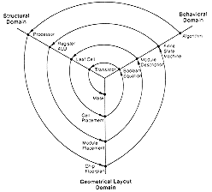
Typical VLSI design flow in three domains (Y-chart representation).
The Y-chart consists of three major domains, namely:
- behavioral domain,
- structural domain,
- geometrical layout domain.
The design flow starts from the algorithm that describes the behavior of the target chip. The corresponding architecture of the processor is first defined. It is mapped onto the chip surface by floorplanning. The next design evolution in the behavioral domain defines finite state machines (FSMs) which are structurally implemented with functional modules such as registers and arithmetic logic units (ALUs). These modules are then geometrically placed onto the chip surface using CAD tools for automatic module placement followed by routing, with a goal of minimizing the interconnects area and signal delays. The third evolution starts with a behavioral module description. Individual modules are then implemented with leaf cells. At this stage the chip is described in terms of logic gates (leaf cells), which can be placed and interconnected by using a cell placement & routing program. The last evolution involves a detailed Boolean description of leaf cells followed by a transistor level implementation of leaf cells and mask generation. In standard-cell based design, leaf cells are already pre-designed and stored in a library for logic design use.

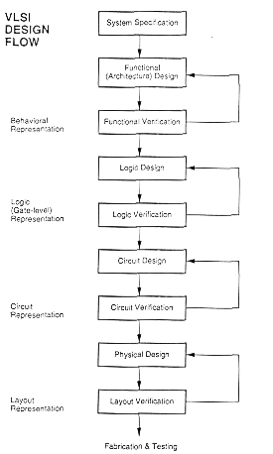

Figure provides a more simplified view of the VLSI design flow, taking into account the various representations, or abstractions of design - behavioral, logic, circuit and mask layout. Note that the verification of design plays a very important role in every step during this process. The failure to properly verify a design in its early phases typically causes significant and expensive re-design at a later stage, which ultimately increases the time-to-market.
Although the design process has been described in linear fashion for simplicity, in reality there are many iterations back and forth, especially between any two neighboring steps, and occasionally even remotely separated pairs. Although top-down design flow provides an excellent design process control, in reality, there is no truly unidirectional top-down design flow. Both top-down and bottom-up approaches have to be combined. For instance, if a chip designer defined an architecture without close estimation of the corresponding chip area, then it is very likely that the resulting chip layout exceeds the area limit of the available technology. In such a case, in order to fit the architecture into the allowable chip area, some functions may have to be removed and the design process must be repeated. Such changes may require significant modification of the original requirements. Thus, it is very important to feed forward low-level information to higher levels (bottom up) as early as possible.
In the following, we will examine design methodologies and structured approaches which have been developed over the years to deal with both complex hardware and software projects. Regardless of the actual size of the project, the basic principles of structured design will improve the prospects of success. Some of the classical techniques for reducing the complexity of IC design are: Hierarchy, regularity, modularity and locality.

Design Hierarchy
The use of hierarchy, or “divide and conquer” technique involves dividing a module into sub- modules and then repeating this operation on the sub-modules until the complexity of the smaller parts becomes manageable. This approach is very similar to the software case where large programs are split into smaller and smaller sections until simple subroutines, with well-defined functions and interfaces, can be written. In Section 1.2, we have seen that the design of a VLSI chip can be represented in three domains. Correspondingly, a hierarchy structure can be described in each domain separately. However, it is important for the simplicity of design that the hierarchies in different domains can be mapped into each other easily.
As an example of structural hierarchy, Fig. 1.6 shows the structural decomposition of a CMOS four-bit adder into its components. The adder can be decomposed progressively into one- bit adders, separate carry and sum circuits, and finally, into individual logic gates. At this lower level of the hierarchy, the design of a simple circuit realizing a well-defined Boolean function is much more easier to handle than at the higher levels of the hierarchy.
In the physical domain, partitioning a complex system into its various functional blocks will provide a valuable guidance for the actual realization of these blocks on chip. Obviously, the approximate shape and size (area) of each sub-module should be estimated in order to provide a useful floorplan. Figure 1.7 shows the hierarchical decomposition of a four-bit adder in physical description (geometrical layout) domain, resulting in a simple floorplan. This physical view describes the external geometry of the adder, the locations of input and output pins, and how pin locations allow some signals (in this case the carry signals) to be transferred from one sub-block to the other without external routing. At lower levels of the physical hierarchy, the internal mask
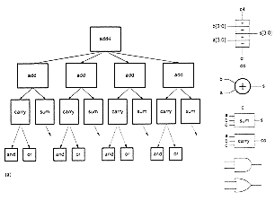
Figure: Structural decomposition of a four-bit adder circuit, showing the hierarchy down to gate level.
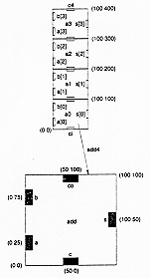
Figure: Hierarchical decomposition of a four-bit adder in physical (geometrical) description domain.
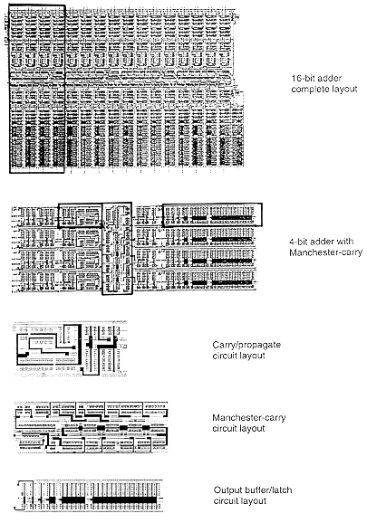
Figure: Layout of a 16-bit adder, and the components (sub-blocks) of its physical hierarchy.
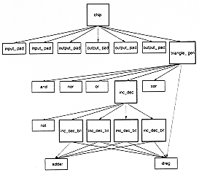
Figure: The structural hierarchy of a triangle generator chip.
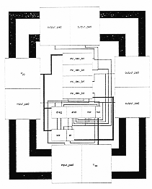
Figure: Physical layout of the triangle generator chip.
layout of each adder cell defines the locations and the connections of each transistor and wire. Figure 1.8 shows the full-custom layout of a 16-bit dynamic CMOS adder, and the sub-modules that describe the lower levels of its physical hierarchy. Here, the 16-bit adder consists of a cascade connection of four 4-bit adders, and each 4-bit adder can again be decomposed into its functional blocks such as the Manchester chain, carry/propagate circuits and the output buffers. Finally, Fig. 1.9 and Fig. 1.10 show the structural hierarchy and the physical layout of a simple triangle generator chip, respectively. Note that there is a corresponding physical description for every module in the structural hierarchy, i.e., the components of the physical view closely match this structural view.

VLSI Design Styles
Several design styles can be considered for chip implementation of specified algorithms or logic functions. Each design style has its own merits and shortcomings, and thus a proper choice has to be made by designers in order to provide the functionality at low cost.

1 Field Programmable Gate Array (FPGA)
Fully fabricated FPGA chips containing thousands of logic gates or even more, with programmable interconnects, are available to users for their custom hardware programming to realize desired functionality. This design style provides a means for fast prototyping and also for cost-effective chip design, especially for low-volume applications. A typical field programmable gate array (FPGA) chip consists of I/O buffers, an array of configurable logic blocks (CLBs), and programmable interconnect structures. The programming of the interconnects is implemented by programming of RAM cells whose output terminals are connected to the gates of MOS pass transistors. A general architecture of FPGA from XILINX is shown in Fig.. A more detailed view showing the locations of switch matrices used for interconnect routing is given in Fig..
A simple CLB (model XC2000 from XILINX) is shown in Fig. It consists of four signal input terminals (A, B, C, D), a clock signal terminal, user-programmable multiplexers, an SR-latch, and a look-up table (LUT). The LUT is a digital memory that stores the truth table of the Boolean function. Thus, it can generate any function of up to four variables or any two functions of three variables. The control terminals of multiplexers are not shown explicitly in Fig.
The CLB is configured such that many different logic functions can be realized by programming its array. More sophisticated CLBs have also been introduced to map complex functions. The typical design flow of an FPGA chip starts with the behavioral description of its functionality, using a hardware description language such as VHDL. The synthesized architecture is then technology-mapped (or partitioned) into circuits or logic cells. At this stage, the chip design is completely described in terms of available logic cells. Next, the placement and routing step assigns individual logic cells to FPGA sites (CLBs) and determines the routing patterns among the cells in accordance with the netlist. After routing is completed, the on-chip
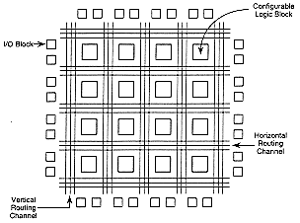
Figure: General architecture of Xilinx FPGAs.
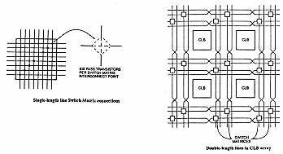
Figure-: Detailed view of switch matrices and interconnection routing between CLBs.
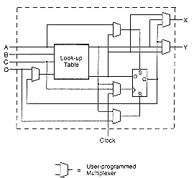
Figure-: XC2000 CLB of the Xilinx FPGA.
performance of the design can be simulated and verified before downloading the design for programming of the FPGA chip. The programming of the chip remains valid as long as the chip is powered-on, or until new programming is done. In most cases, full utilization of the FPGA chip area is not possible - many cell sites may remain unused.
The largest advantage of FPGA-based design is the very short turn-around time, i.e., the time required from the start of the design process until a functional chip is available. Since no physical manufacturing step is necessary for customizing the FPGA chip, a functional sample can be obtained almost as soon as the design is mapped into a specific technology. The typical price of FPGA chips are usually higher than other realization alternatives (such as gate array or standard cells) of the same design, but for small-volume production of ASIC chips and for fast prototyping, FPGA offers a very valuable option.

2 Gate Array Design
In view of the fast prototyping capability, the gate array (GA) comes after the FPGA. While the design implementation of the FPGA chip is done with user programming, that of the gate array is done with metal mask design and processing. Gate array implementation requires a two-step manufacturing process: The first phase, which is based on generic (standard) masks, results in an array of uncommitted transistors on each GA chip. These uncommitted chips can be stored for later customization, which is completed by defining the metal interconnects between the transistors of the array (Fig. 1.15). Since the patterning of metallic interconnects is done at the end of the chip fabrication, the turn-around time can be still short, a few days to a few weeks. Figure 1.16 shows a corner of a gate array chip which contains bonding pads on its left and bottom edges, diodes for I/O protection, nMOS transistors and pMOS transistors for chip output driver circuits in the neighboring areas of bonding pads, arrays of nMOS transistors and pMOS transistors, underpass wire segments, and power and ground buses along with contact windows.
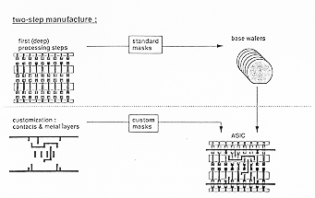
Figure: Basic processing steps required for gate array implementation.
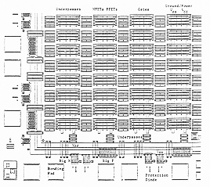
Figure: A corner of a typical gate array chip.
Figure shows a magnified portion of the internal array with metal mask design (metal lines highlighted in dark) to realize a complex logic function. Typical gate array platforms allow dedicated areas, called channels, for intercell routing as shown in Figs. between rows or columns of MOS transistors. The availability of these routing channels simplifies the interconnections, even using one metal layer only. The interconnection patterns to realize basic logic gates can be stored in a library, which can then be used to customize rows of uncommitted transistors according to the netlist. While most gate array platforms only contain rows of uncommitted transistors separated by routing channels, some other platforms also offer dedicated memory (RAM) arrays to allow a higher density where memory functions are required. Figure shows the layout views of a conventional gate array and a gate array platform with two dedicated memory banks.
With the use of multiple interconnect layers, the routing can be achieved over the active cell areas; thus, the routing channels can be removed as in Sea-of-Gates (SOG) chips. Here, the entire chip surface is covered with uncommitted nMOS and pMOS transistors. As in the gate array case, neighboring transistors can be customized using a metal mask to form basic logic gates. For intercell routing, however, some of the uncommitted transistors must be sacrificed. This approach results in more flexibility for interconnections, and usually in a higher density. The basic platform of a SOG chip is shown in Fig. 1.19. Figure 1.20 offers a brief comparison between the channeled (GA) vs. the channelless (SOG) approaches.
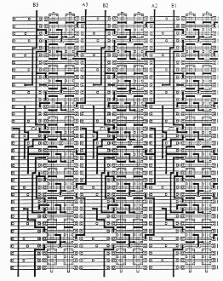
Figure: Metal mask design to realize a complex logic function on a channeled GA platform.
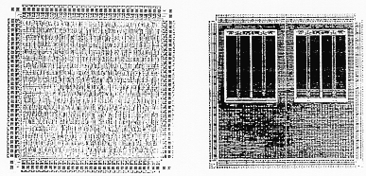
Figure: Layout views of a conventional GA chip and a gate array with two memory banks.
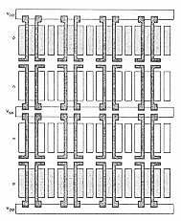
Figure: The platform of a Sea-of-Gates (SOG) chip.
In general, the GA chip utilization factor, as measured by the used chip area divided by the total chip area, is higher than that of the FPGA and so is the chip speed, since more customized design can be achieved with metal mask designs. The current gate array chips can implement as many as hundreds of thousands of logic gates.
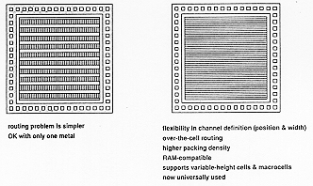
Figure: Comparison between the channeled (GA) vs. the channelless (SOG) approaches.

3 Standard-Cells Based Design
The standard-cells based design is one of the most prevalent full custom design styles which require development of a full custom mask set. The standard cell is also called the polycell. In this design style, all of the commonly used logic cells are developed, characterized, and stored in a standard cell library. A typical library may contain a few hundred cells including inverters, NAND gates, NOR gates, complex AOI, OAI gates, D-latches, and flip-flops. Each gate type can have multiple implementations to provide adequate driving capability for different fanouts. For instance, the inverter gate can have standard size transistors, double size transistors, and quadruple size transistors so that the chip designer can choose the proper size to achieve high circuit speed and layout density. The characterization of each cell is done for several different categories. It consists of
- delay time vs. load capacitance
- circuit simulation model
- timing simulation model
- fault simulation model
- cell data for place-and-route
- mask data
To enable automated placement of the cells and routing of inter-cell connections, each cell layout is designed with a fixed height, so that a number of cells can be abutted side-by-side to form rows. The power and ground rails typically run parallel to the upper and lower boundaries of the cell, thus, neighboring cells share a common power and ground bus. The input and output pins are located on the upper and lower boundaries of the cell. Figure 1.21 shows the layout of a typical standard cell. Notice that the nMOS transistors are located closer to the ground rail while the pMOS transistors are placed closer to the power rail.
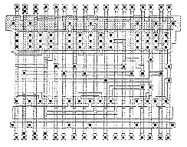
Figure: A standard cell layout example.
Figure shows a floorplan for standard-cell based design. Inside the I/O frame which is reserved for I/O cells, the chip area contains rows or columns of standard cells. Between cell rows are channels for dedicated inter-cell routing. As in the case of Sea-of-Gates, with over-the- cell routing, the channel areas can be reduced or even removed provided that the cell rows offer sufficient routing space. The physical design and layout of logic cells ensure that when cells are placed into rows, their heights are matched and neighboring cells can be abutted side-by-side, which provides natural connections for power and ground lines in each row. The signal delay, noise margins, and power consumption of each cell should be also optimized with proper sizing of transistors using circuit simulation.
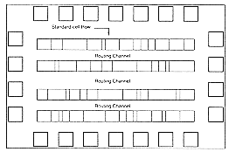
Figure: A simplified floorplan of standard-cells-based design.
If a number of cells must share the same input and/or output signals, a common signal bus structure can also be incorporated into the standard-cell-based chip layout. Figure 1.23 shows the simplified symbolic view of a case where a signal bus has been inserted between the rows of standard cells. Note that in this case the chip consists of two blocks, and power/ground routing must be provided from both sides of the layout area. Standard-cell based designs may consist of several such macro-blocks, each corresponding to a specific unit of the system architecture such as ALU, control logic, etc.
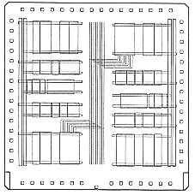
Figure: Simplified floorplan consisting of two separate blocks and a common signal bus.
After chip logic design is done using standard cells in the library, the most challenging task is to place individual cells into rows and interconnect them in a way that meets stringent design goals in circuit speed, chip area, and power consumption. Many advanced CAD tools for place-and-route have been developed and used to achieve such goals. Also from the chip layout, circuit models which include interconnect parasitics can be extracted and used for timing simulation and analysis to identify timing critical paths. For timing critical paths, proper gate sizing is often practiced to meet the timing requirements. In many VLSI chips, such as microprocessors and digital signal processing chips, standard-cells based design is used to implement complex control logic modules. Some full custom chips can be also implemented exclusively with standard cells.
Finally, Fig. 1.24 shows the detailed mask layout of a standard-cell-based chip with an uninterrupted single block of cell rows, and three memory banks placed on one side of the chip. Notice that within the cell block, the separations between neighboring rows depend on the number of wires in the routing channel between the cell rows. If a high interconnect density can be achieved in the routing channel, the standard cell rows can be placed closer to each other, resulting in a smaller chip area. The availability of dedicated memory blocks also reduces the area, since the realization of memory elements using standard cells would occupy a larger area.
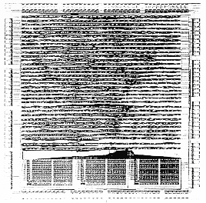
Figure: Mask layout of a standard-cell-based chip with a single block of cells and three memory banks.

4 Full Custom Design
Although the standard-cells based design is often called full custom design, in a strict sense, it is somewhat less than fully custom since the cells are pre-designed for general use and the same cells are utilized in many different chip designs. In a fuller custom design, the entire mask design is done anew without use of any library. However, the development cost of such a design style is becoming prohibitively high. Thus, the concept of design reuse is becoming popular in order to reduce design cycle time and development cost. The most rigorous full custom design can be the design of a memory cell, be it static or dynamic. Since the same layout design is replicated, there would not be any alternative to high density memory chip design. For logic chip design, a good compromise can be achieved by using a combination of different design styles on the same chip, such as standard cells, data-path cells and PLAs. In real full-custom layout in which the geometry, orientation and placement of every transistor is done individually by the designer, design productivity is usually very low - typically 10 to 20 transistors per day, per designer.
In digital CMOS VLSI, full-custom design is rarely used due to the high labor cost. Exceptions to this include the design of high-volume products such as memory chips, high- performance microprocessors and FPGA masters. Figure 1.25 shows the full layout of the Intel 486 microprocessor chip, which is a good example of a hybrid full-custom design. Here, one can identify four different design styles on one chip: Memory banks (RAM cache), data-path units consisting of bit-slice cells, control circuitry mainly consisting of standard cells and PLA blocks.
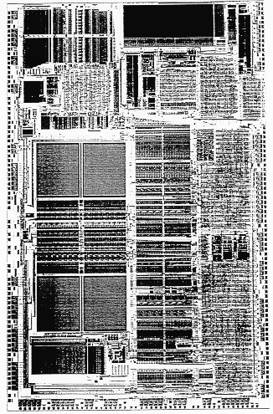
Figure: Mask layout of the Intel 486 microprocessor chip, as an example of full-custom design.
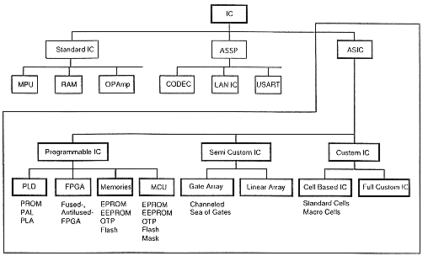
Figure: Overview of VLSI design styles

